Computer Architecture

Lab 1

**General Questions**

**Part A**

1. Who is regarded as the first programmer?

Ans:madam Ada Lovelace

1. What was the name of the first computer to be shipped with a graphical user interface? Was it successful?

Ans:Apple Lisa

1. In lectures we discussed three different generations of computer architectures, explain what instigated the evolutionary jump for each generation of computer architecture.

* Ans:the first generation computers used vacuum tubes . The stimulus for the electronic computer was World War 2. The English built a machine called COLOSSUS (with Alan Turings help) to decipher messages encrypted using the German ENIGMA machine.
* The second generation computers used Transistors. The stimulus for the electronic computer was World War 2. The English built a machine called COLOSSUS (with Alan Turings help) to decipher messages encrypted using the German ENIGMA machine.
* The third generation computers used Integrated circuits. The invention of the silicon integrated circuit by Robert Noyce in 1958 allowed dozens of transistors to be placed on a single chip. This meant smaller, faster and cheaper computers.

1. PDP-8 had a major innovation, what was it? How did this significantly improve the microcomputer industry?

ANS:Pdp is the 12 bit circuit (single bus and Omni bus).

1. Draw a diagram of the Von Neumann machine, illustrating the flow of communication. How is this related to more recent machines?

s

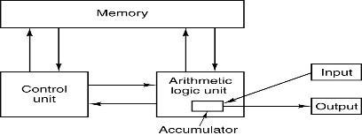

1. In your opinion what will the next generation of computers be?

*Ans the next generation of computers would be Artificial intelligence combined with deep neural learning(human machine learning).*

**Part B**

1. Create a Finite State Machine to recognise all the words in the following language: *L={a, aab, abab, abb}*
2. Draw a Finite State Machine that is capable of recognizing the following alphabet: L={ABAB, BBA, BBB, ABABAB}

